3 person cloud consultancy hired to help medical startup with AWS implementation

Project details:

* Goal: Presentation on designed solution
* Graded
  + Good to have equal effort among 3 team members
* Wednesday the 21st or Monday the 26th
  + 10-15 minutes or so
  + Can at a minimum talk from supplied worksheets
    - Better to provide powerpoint!
* Talk with members:
  + How work is divied up
  + Exchange contact information

Company background:

* A Medical Company is a startup software as a service

Current environment:

* Current development and test infrastructure with server hosting company
* 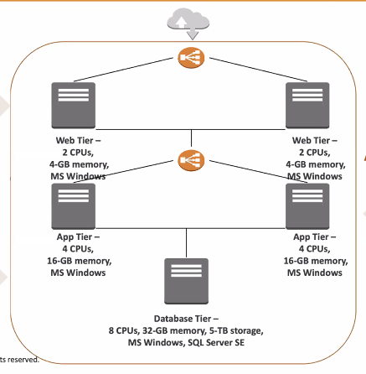Uses Windows servers to host web and application tiers with MS SQL Server Standard Edition backend databses
* Application launch data is coming soon
* Believes would be best to use cloud to support rapid growth

Web Tier:

* Two physical servers (2 CPUs / 4-GB memory)
* MS Windows 2016 base with internet information service
* High availability proxy load balancer used to balance traffic between web servers

Database Tier:

* One physical server (8 CPUs / 32 GB memory / 5TB storage)
* SQL Server Standard Edition with MS Windows 2016 base
* DBAs access and manage database, but no RDMS or advanced config required

Application tier:

* Two physical servers (4 CPUs / 16GB memory)
* MS Windows 2016 base with Internet Information Services
* High availability load balancer used to balance traffic between app servers